"We Lost One Kittyhawk..."

By Alec Richardson.
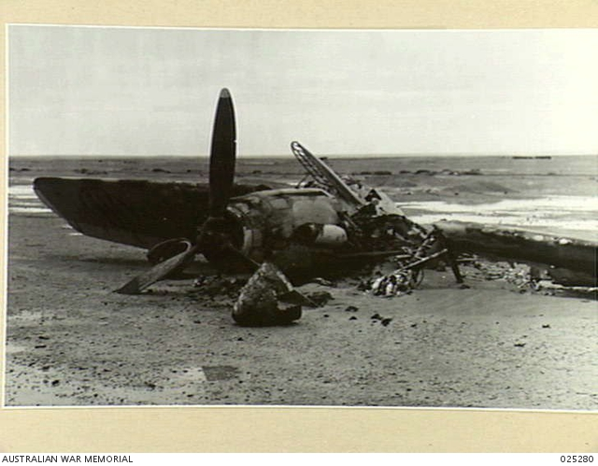
FUKA, EGYPT. 1942-11-13. ITALIAN MACCHI C.202 FIGHTER PLANE FOUND WRECKED
ON FUKA AIRFIELD WHEN OCCUPIED BY ALLIED FORCES.
"We lost one Kittyhawk"-So said the official story of Air Operations in the Middle East of 25th October, 1942.
The Italian History was more explicit:
"Sergeant A. F. (J) Richardson was shot down by Giuseppe Oblach."
It started innocently enough, an early-morning sortie escorting Baltimores and Mitchells.
After the usual bath in the gallon of water, I was attending to my daily letter-writing in the mess when I noticed that my name had replaced Ken Bee's on the Flight Board for the next sortie, an escort to bomb the Italians at Fuka. Ken had just returned from a month in hospital after being hit by fragments of a 109's 20mm so the change was understandable. Little did I know it was to be my last flight.
From the outset it was a disaster. The cockpit check disclosed a faulty reflector sight, which was not rectified by a globe taken from Squadron Leader Bob Gibbes' plane alongside. In the middle of all this we were given the signal to take off and being a little slow I took off in someone's dust until 80 mph when I pulled out of it. (Jim Churchill told me some weeks later in Benghazi POW Camp that he and two others had been left too little room to get off and had abandoned the Op).
As usual the Macchis jumped us over their drome and in the fight that followed I noticed a Kitty with a Macchi 202 firing into it from very close range. Thinking he would not make it but I would have to help, I tried to use the fixed ring-and-bead sight and spent so much time trying to line these two up that a Macchi got a burst in before I got away. One wheel dropped so I continued diving full bore for the dirt 7,000 feet below, probably exceeding the maximum speed of 360 mph recommended on the instrument panel, as I was doing 350 after flattening out. As I did a very careful steep turn to see if he had followed me down, I saw his tracer just miss the tailplane. Whilst we were both doing high speed steep turns, all the instruments fell off and I had no motor. As usual the Kitty held its speed after the dive, just when I did not need it, as I had to land and fast. So I fish-tailed it, ignoring the Macchi, and when the speed dropped to around 170-180mph whacked it on the ground literally and after a few bounces it came to rest. After pressing the two I.F.F. (Identification Friend or Foe) buttons to destroy it, I hopped out. I don't remember turning off the engine but must have done so.
In the distance the Italian pilot turned and then bored straight at me. I really thought he intended to shoot and when I thought he was about to let me have a burst, I ducked down behind the engine (this was to cause me some embarrassment later). After amusing himself a couple of times he took off and so did I, clutching a spare water bottle and 12 loose Sao biscuits from the luggage compartment. East was too obvious, so I headed North (until night time I thought) but only got about 400 yards when a truck carrying five German soldiers appeared over a rise, went to the plane and then came looking for me. When one was about 30 yards from me with his revolver pointing at my heart I stood up hands raised. After he took my 38 (still wrapped in 4 x 2) he was quite friendly and spoke English. Taking me back to the plane, they pointed to the I.F.F. and said "What's that?"I said"I don't know, I'm only the pilot". Just then a Fieseler Storch flew up, landed and a chap with a machine pistol got out. He nattered to the Germans who apparently refused to hand me over until he pointed the gun at them.
The English-speaking German said, "It looks as though you'd better go," so reluctantly I did. He motioned me into the back seat and after putting the gun on the floor with the barrel pointing at my chin he sat alongside me and said "Nom?" I said "Alec Richardson", he said "Oblach" I said "German?" he said "Nord Italia". End of conversation.
After a short flight, the pilot in front landed back at Fuka, taxiing up to what seemed like hundreds waiting for us. When I stepped down, the Officer I took to be the C.O. came up to me, put his face about six inches from mine and said, "I don't speak much English but Australians are TERRIBLE!" The last word almost spat in my face. I was shaken and for once had nothing to say.
I was ushered into one of the rooms on the station and was interrogated by an Italian Officer in the best English I have ever heard - not a trace of an accent. After I had told him the usual name, rank and number, he said, "In 239 Wing there are 3 Squadron, 112, 250 and 450; which one are you?" I did not answer but he must have known I was 3. He also said, "Why did you get down behind your engine? Did you think he was going to shoot you?" I said "Yes" and he said, "Is that what you do?"
My "no" sounded pretty lame.
The pilots were very experienced and some had fought in the Spanish War. Some came around to my tent for a chat but not much was said as they did not speak English. One even indicated by pointing to a World Map that Germany and Italy could not win the war by saying "Nix Victoria."
The second day I was standing in a corridor near their Ops Room when a soldier came up to me and in English said, "You British can't fly for shit!"
I said, "Where did you learn your English?"
He said, "I had an ice cream cart in Edinburgh before the war".
That afternoon they asked me to come and watch the P40s. Sure enough, they were jumped over the drome and a Macchi was shot down but unfortunately the Kitty pilot was shot down by his mate and we met later. They were astounded when it was obvious we had never seen each other before. He was an Englishman with eighteen months desert experience with another wing.
Once we were handed over to the Italian Army, our daily rations were cut so much that we gradually became very weak. We were taken by truck all the way to Tripoli where we joined a ship for Palermo in Sicily. On the way across in the hold we had our first experience of lice. The hold was so crowded that everyone could not lie down at once, which meant the lice had no trouble going from one body to another.
In Italy we were deloused and sent to camp No.57 near Udine. Jim Edwards and Sandy Mostran, original 3 Squadron members, were already there. I joined them, to be followed by Jim Churchill, Sandy Jones, Alan Righetti and Joe Holder.
In September 1943 when Italy capitulated we were in a euphoric state, but suffered a terrible let-down when we found Germans in the guard boxes next morning. The Commandant, Colonel Calcaterra, a leading Fascist, had handed over the camp to them.
From there we went by cattle trucks (40 men or 8 horses) to Stalag IVB in Germany via Austria. IVB was about 80km south of Berlin and housed 30,000 POW'S in three-decker beds on 80 acres. Of this number, 10,000 were British including 2,000 N.C.O. air crew.
The Luftwaffe relieved our boredom by flying low over a long field and going over the Air Force compound at about 100 feet. This went on until one pilot misjudged his height, hit a telegraph post, slewed into the camp killing a Canadian pilot and injuring another, went through two barbed wire fences, before staggering out of the camp and back to his drome.
One of the RAF chaps had a mother living in Germany who used to visit him. To protect her from the Russians she was smuggled into the camp as a soldier and eventually was evacuated back to England with him after the war.
After the Warsaw Insurrection, one thousand Polish girls, captured during the fighting, were placed under strict guard in a compound next to ours for a few months. They provided a pleasant diversion as most POW's had not seen a female for years.
For the last nine months of the war, Jim Edwards and I represented the Air Force in the camp's Post Office of 72 personnel. Most camps were evacuated ahead of the Russians or Allies but IVB ended up in a ten-mile corridor between the Russian and American armies. In fact there was a token meeting for propaganda purposes at Torgau not far from us.
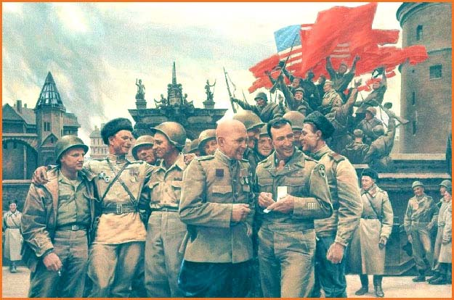
Torgau April 25th 1945. [Propaganda painting.]
The last few weeks were full of tension and apprehension. This was especially so after American fighters strafed the camp killing a few POWs.
On 6th May 1945, the Russians marched the British out to Riesa, a nearby city. At first were in fives, then fours then threes until after a while there was a single line as far as the eye could see up and down the hills.
We were installed in German barracks and our particulars taken down. I went through at 2.30am. After hearing Churchill say that we must not forget what we started fighting the war for and thinking he was about to fight the Russians, Jim Churchill, Frank Beste (450), Pat Northway (Wellington) and I took off through the back gate which was not guarded.
Not far away we ran into two Americans and two New Zealand Officers who were on their way to the camp to tell them to stay put but gave us cigarettes and told us to keep going.
In about two and a half hours we made Oshatz. Jim and Frank went off to see the town and whilst we were waiting for them a woman asked us in English if we wanted Billets for the night. Pat and I ended up with her family of mother and two young girls, Jim with a South African POW living with a German girl and Frank with an ex-German General and his wife. We were in modern flats and they were very comfortable but we left the next day when the Russian army established itself around us.
Our next night was spent in a school house in Wermsdorf. At 1.30am we were awakened by having cigars thrust into our mouths by a grinning Russian soldier. Jim and Frank had run into him earlier in the night when sightseeing and had discovered he had been in Stalag IVB. He now proceeded to tell us, in German, what happened after he left the camp. First he had got a revolver and proceeded to knock off all the Germans who had treated him badly when he worked for them. As he illustrated everything by waving his revolver about and saying, "bang bang!" we were relieved when he took off. He did tell us that his unit was going to fight the Japs though.
The next morning we took off for Trebsen and came to a river with a Russian on our side and an American on the other. After satisfying the Russian that we were ex-POW's by showing our German dog tags, we crossed the river and were free.
The Yank had a truck waiting which took up to Halle where we spent a few days before flying off to Rheims and then to Dunsfold, England on 23rd May and a wonderful welcome.
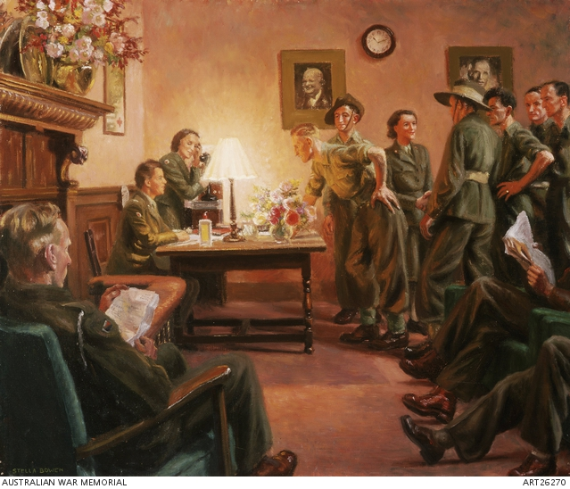
Reception desk at Gowrie House, Eastbourne. [Painting by Stella Bowen, Copyright AWM ART26270]
Upon arrival at the Australian prisoner of war repatriation centre at Eastbourne, the men were provided with a meal and accommodation. After settling in, they were allowed to send a free cable home and were presented with a Red Cross parcel. The men were presented with new uniforms and pay advances and then given 14 days leave and rail passes to explore Britain. Upon their return, they awaited embarkation to Australia. In this painting, Bowen has captured a friendly gathering of ex-prisoners of war with Women's Auxiliary Air Force officers, the group framed by the warmth of a desk lamp and watched over benevolently by portraits of Winston Churchill and John Curtin.

