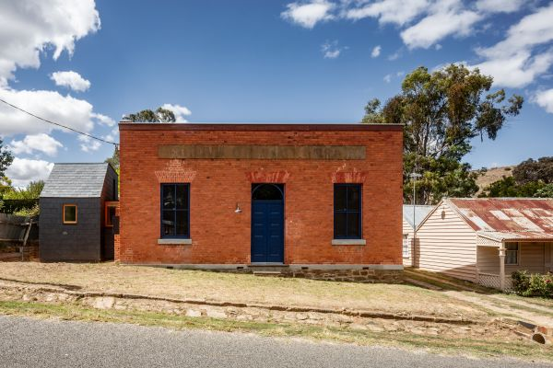
An 1850s ruin was spectacularly enlivened again thanks to some clever thinking and an aptitude for restoration. Photo: Trevor Mein

‘Restore the old dame’: How a crumbling bank building in central Victoria was saved
Jenny BrownWriterMar 26, 2019

In a heartbreaking era when so much built heritage is lost or damaged through demolition or unfortunate addition, this story delivers a great outcome. A Victorian bank building – built in brick in the 1850s to deal with the improbable amounts of ore being dug from one of the richest goldfields the world had ever known – has been restored.
Though empty and dilapidated, the four-room building on the main street of Vaughan – a little village of 300 near Castlemaine about 130 kilometres north-west of Melbourne – had just enough of its dignity intact to entice two passers-by. They spontaneously put down a deposit after noticing the auction only as they drove past.
The Melbourne-based cook and writer couple had already downsized in Melbourne’s northern suburbs but were planning to add a country property to their portfolio. Having long appreciated the historic charm and scenic beauty of Vaughan and its surrounds, and because they saw it as affordable, it was a “no brainer” to buy the bank.
In a heartbreaking era when so much built heritage is lost or damaged through demolition or unfortunate addition, this story delivers a great outcome. A Victorian bank building – built in brick in the 1850s to deal with the improbable amounts of ore being dug from one of the richest goldfields the world had ever known – has been restored.
Though empty and dilapidated, the four-room building on the main street of Vaughan – a little village of 300 near Castlemaine about 130 kilometres north-west of Melbourne – had just enough of its dignity intact to entice two passers-by. They spontaneously put down a deposit after noticing the auction only as they drove past.
The Melbourne-based cook and writer couple had already downsized in Melbourne’s northern suburbs but were planning to add a country property to their portfolio. Having long appreciated the historic charm and scenic beauty of Vaughan and its surrounds, and because they saw it as affordable, it was a “no brainer” to buy the bank.
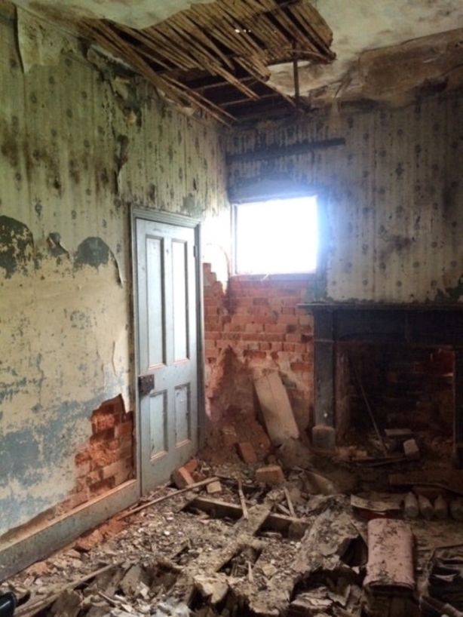
A massive task awaited the purchasers and the architect when they got to work. Photo: Maria Danos
Given the state of the place, with falling ceilings, failing floors and layers of wallpaper and lathe and plaster peeling like sunburnt skin to reveal soft red structural brick, it’s fortunate “they love restoration”, says Maria Danos, an architect who’d worked with the clients previously. Her brief for this project? “Restore the old dame.”
The bank hadn’t operated as such through three generations of one family’s ownership. It recently just dodged the irretrievable change of gaining a modern rear extension “that would have chopped off one of the most important spaces, the north-facing back verandah”, Danos says.
Despite having to step through “the sensory assault of rat droppings”, when she first visited, Danos says: “I was excited. I could see the volumes of elegance of the two front office rooms, and the manager’s living room and one bedroom behind.
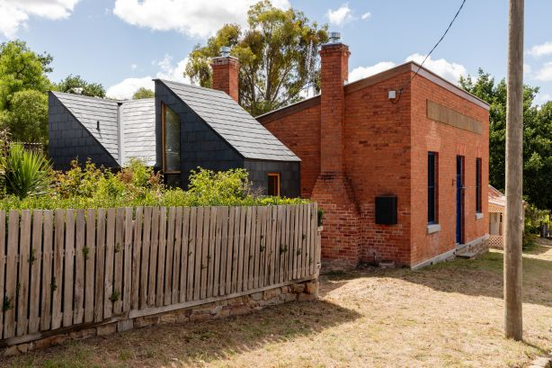
Attached to the side of the building is a new kitchen and bathroom. Photo: Trevor Mein
“In the 100 square metres, there was enough that was original to give it a very strong presence in the heart of the village,” Danos says.
The bathroom and outhouse had, along with the backyard smelting works, long been lost, so the building that was to become a semi-permanent home and occasional venue for writing and cooking workshops needed a new amenities block.
Relying on the expertise of local artisans, supervised by project facilitator Debbie Taylor, the failing brickwork was restored where needed, the few usable Baltic pine floorboards were repurposed and applied to the top of the bathroom wall, and the floors throughout were replaced with wide boards of recycled spotted gum.
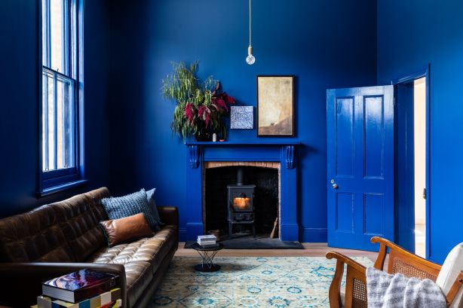
The bold living room colour was inspired by the original wallpaper. Photo: Trevor Mein
The wallpapers were too far gone but did become the inspiration for the bold blue that is the whole tonality of the sitting room, the trim of door and window surrounds, and the kitchen datum.
It’s a big lot of blueness but it was already there, the architect says, even when the place was a ruin.
“Every room had its own type of wallpaper, and it was the main room, with a floral wallpaper that graded through all sorts of blues – from light to dark, and that was also threaded with gold – that really inspired us. The wallpapers and that colour had such a richness that they bought back the civic idea of the function of the bank.”
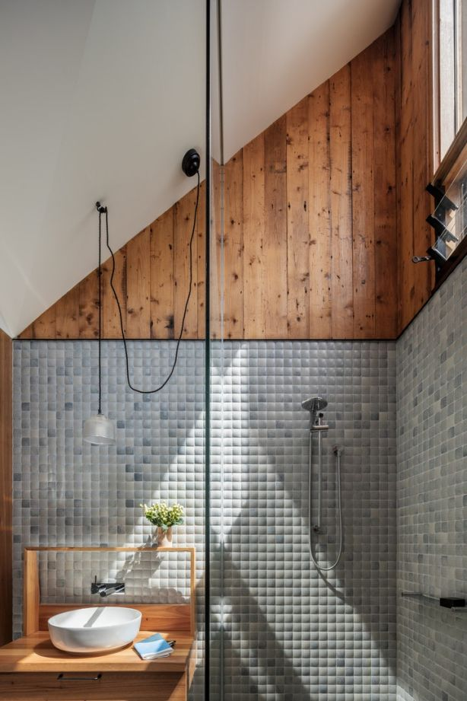
The new, contemporary bathroom is contained in a service pod attached to the side of the original building.
Photo: Trevor Mein
All through this utterly delightful heritage job, Danos says she and her clients kept in mind that everything they did “needed to talk to the original bank”.
In a commendably restrained move, Danos made the “service pod” that contains an extension to the kitchen and a contemporary bathroom so unpretentious that the interestingly angular addition with the slate-clad walls and roof stands aside from the elegant chimneys and, unusual-for-the-time, skillion roof to visually project what the architect says are the qualities she always looks for in her work.
“Context, culture and expression. I always try to find the soul in a building and hope to honour that,” she says.
mariadanos.com.au

